

**DANANG SOFTWARE DANANG SOFTWARE CORPORATION**

**SOFTECH-APTECH**



**PROJECT TITLE**

**(USING APS.NET MVC5)**

**Glasses Shop**

**Members : NGUYEN QUOC HOANG**

**HUYNH NGUYEN PHUONG NAM**

**NGUYEN LE ANH VI**

**Group : 5**

**Batch : 122-123**

Danang, 18thMay 2017

**TEACHER’S EVALUATION**

lIST

**I. THANKS FOR 4**

**II. INTRODUCTION 4**

**III. PROBLEM DEFINITION 6**

*1. Homepage 6*

*2. Category Page 6*

*3. Table Page 7*

*4. Accessory Page 7*

*5. News Page 7*

*6. Mini product information 7*

*7. Product Details Page 7*

*8. Shopping Cart 8*

*9. Payment information 8*

*10. Search 8*

**IV. REQUIREMENT ATTRIBUTES 9**

*1. Main Requirements 9*

*2. Critical Use Case Specification 9*

*3. Usecase diagram 12*

**V. PROJECT PLANNING 14**

**VI. GUI PROTOTYPE 15**

**VII. TECHNICAL 16**

**VIII. REFERENCES 19**

**IX. GUI OF WEBSITE 20**

**X. CHECK LIST 29**

*1. Check List of Validation 29*

*2. Submission Checklist 29*

# I. THANK YOU

# First and foremost, I would like to express my sincere gratitude to the Master of Information Technology at APTECH Center for teaching and helping us through the process of researching and completing the internship and building practice. Create a sem 3 project report.

Finally, we would like to thank the teachers who taught us directly in the past school years, with their friends and relatives who enthusiastically supported and encouraged during the study and construction process. Internship thesis.

*We sincerely thanks to my teacher!*

II. INTRODUCE

Shopping demand has become an indispensable part of everyone today. Their psychology often "likes to buy nice things, have to go to famous shops or shopping malls to get a new trend." But they usually do not buy time because of busy work, family .. and much more. They can not meet their needs.

Get the vision of ecommerce, we have online shopping to buy mobile phones, tablet PCs and accessories, make it convenient, fast, comfortable and save for the user. Selected products will be displayed in tabular form and can be placed online via other payment methods. Site users can buy products online instead of going out of cell phone stores where they can buy books from the home's roof through the Internet. Digital Equipment Store is a virtual shop on the Internet where customers can browse catalogs and select products of interest.

On the web we are our clients, customers may not be about the quality and product, we will be best, best, best and best. Market. .

After that you can find the information you need for the product as well as buy the product you want and finally purchase it using a legal medium. Choose the choice of your choice. When the daytime, rows in the cart will be displayed in the order row. Visit this moment, need more information to complete the transaction. Typically, a customer will be required to enter or select an operator, transaction address, delivery address, and payment option, such as a credit card. A email sent to customer when set.information was needed to complete the transaction. Usually, customers will be asked to enter or select a billing address, shipping address, shipping options, and billing information, such as credit card numbers. An e-mail message is sent to the customer upon ordering.

# Administrators will have additional functionality when compared to regular users. He can add, delete and update product details, product catalogs, member information and order confirmations.

# This application was developed using HTML5, CSS3, jQuery, Material for Bootstrap, ASP.NET MVC ... used to develop Online Shopping.

# III. PROBLEM DEFINITION

# Is an online web application where customers can buy products online. Through a web browser, a customer can search for a product by its name, then can add it to a shopping cart and finally purchase it using your account details or new customers can. Set up a very quick account. They should give the details of their name, contact and shipping address. Users can also provide feedback on a product by sending your feedback to the administrator.

# 1. Home page

# This is the page where the user will be navigated after successful access to the site. This page is showing a few dishes that customers can look through the selection and find the dishes that you like.

# 2. Menu page

# This is the page that customers can view, product by price or see the details of the dish when mouse moves to that product, they can click "Add to Cart" button to add product to cart or click. On the product, the site will be redirected to the product details page.

# 3. Store Page

# 

# 4. Promotion page

# Customers can view the details of the products can be promoted during the holidays to buy cheap goods or other benefits of customers ...

# 5. page of order

# This page is located on the home page, customers can order online with the food they like with the amount of goods, more convenient for customers.

# 6. Detail page of the dish

# Show detailed information of each dish.

# The content of the dessert details page includes: Raw materials, processing, price, color, discussion of food.

# 7. Cart

# Shopping Cart is one of the main features of an ecommerce website and therefore it is the central component of testing ecommerce websites. It allows customers to select and store multiple items in the shopping cart and buy them at the same time. Where to store the items that customers have chosen for when they are ready to purchase

# 8.Payment Information Page

# When the customer completes shopping, it is mandatory to fill in some form of payment information, including: name, address, telephone number, direct online payment, and company invoice.

# IV. REQUIREMENT ATTRIBUTES

## 1. Main Requirements

The Main Requirements include HTML5, CSS3, Material for bootstrap, Jquery

## 2. Critical Use Case Specification

|  |  |  |  |
| --- | --- | --- | --- |
| **Use-case No.** | UC03 | **Use-case Version** | 1.0 |
| **Use-case Name** | *Seacrch-ViewProduct* | | |
| **Purpose:**  A user can view a product detail of his choice by selecting product name. Then a select query is used to retrieve data from the database and display the selected information.  **Input:**  The user will select category, subcategory on the menus provided and select a product name on a data bound provided.  **Output:**  The system will display the product which matches the selected criteria. | | | |

|  |  |  |  |
| --- | --- | --- | --- |
| **USE CASE SPECIFICATION** | | | |
| **Use-case No.** | UC04 | **Use-case Version** | 1.0 |
| **Use-case Name** | *Purchase-Order -Payment* | | |
| **Purpose:**  If the user wants to buy a certain product, they need to provide some information to confirm the purchase.  **Input:**  The user must enter the quantity required and click button “DAT HANG”.  **Output:**  After the payment done, the site will display a notification the payment was successful. | | | |

|  |  |  |  |
| --- | --- | --- | --- |
| **USE CASE SPECIFICATION** | | | |
| **Use-case No.** | UC05 | **Use-case Version** | 1.0 |
| **Use-case Name** | *View Order History* | | |
| **Purpose:**  Users can view their purchase history.  **Input:**  The user logs on to the website to view the purchase history.  **Output:**  The database retrieves the user's purchase history. | | | |

|  |  |  |  |
| --- | --- | --- | --- |
| **USE CASE SPECIFICATION** | | | |
| **Use-case No.** | UC07 | **Use-case Version** | 1.0 |
| **Use-case Name** | *Supports Online* | | |
| **Purpose:**  The new trend for good, fast and cheap demand is guaranteed to bring you incredible benefits in your limited time.  **Input:**  Customers order food online with focus on: NGON, QUICK, WELL, LOST.  **Output:**  Service to eat through the internet service to determine quality, service, product, utility, always to the most trusted site for any clients. | | | |

|  |  |  |  |
| --- | --- | --- | --- |
| **Use-case No.** | UC08 | **Use-case Version** | 1.0 |
| **Use-case Name** | *View News* | | |
| **Purpose:**  Provides information about the menu, so customers can select many items  **Input:**  The customer enters the menu page  **Output:**  Updated daily dishes for customers. | | | |

**Administrator use case diagram**

|  |  |  |  |
| --- | --- | --- | --- |
| **Use-case No.** | UC01 | **Use-case Version** | 1.0 |
| **Use-case Name** | **Manage Category Product** | | |
| **Purpose:**  Admin product manager. Add, delete, edit product information, customers, news **Input:**  Admin log into his account to manage additional services, delete, edit.  **Output:**  Manager display when admin login. | | | |

|  |  |  |  |
| --- | --- | --- | --- |
| **Use-case No.** | UC02 | **Use-case Version** | 1.0 |
| **Use-case Name** | *Manage Order* | | |
| **Purpose:**  Admin manages orders that users purchase.  **Input:**  Admin log into his account to manage orders.  **Output:**  Manager display when admin login. | | | |

|  |  |  |  |
| --- | --- | --- | --- |
| **Use-case No.** | UC03 | **Use-case Version** | 1.0 |
| **Use-case Name** | *Manage Customer* | | |
| **Purpose:**  customer management  **Input:**  Admin log into his account to manage clients.  **Output:**  Manager display when admin login. | | | |
|  | | | |

|  |  |  |  |
| --- | --- | --- | --- |
| **Use-case No.** | UC04 | **Use-case Version** | 1.0 |
| **Use-case Name** | *Update News* | | |
| **Purpose:**  Import new and popular dishes. Provide the latest promotion information to customers.  **Input:**  Admin log into his account to edit and update news.  **Output:**  Admin page displayed when admin login. Allow admin to perform update news | | | |

|  |  |  |  |
| --- | --- | --- | --- |
| **Use-case No.** | UC05 | **Use-case Version** | 1.0 |
| **Use-case Name** | *Item Statistics* | | |
| **Purpose:**  **Input:**  **Output:** | | | |

## 3. Usecase diagram

**View Wedsite**

**Sign Up**

**Search -ViewProduct**



**Contact**

**Purchase -Order-Payment**

***Customer***

**Comment,Evaluate The Product**

**View News**

***Customer usecase diagram***

**Manage Category Product**

**Manage Order**



**Manage Customer**

***Administrator***

**Update News**

**Item Statistics**

**Administrator use case diagram**

# V. PROJECT PLANNING

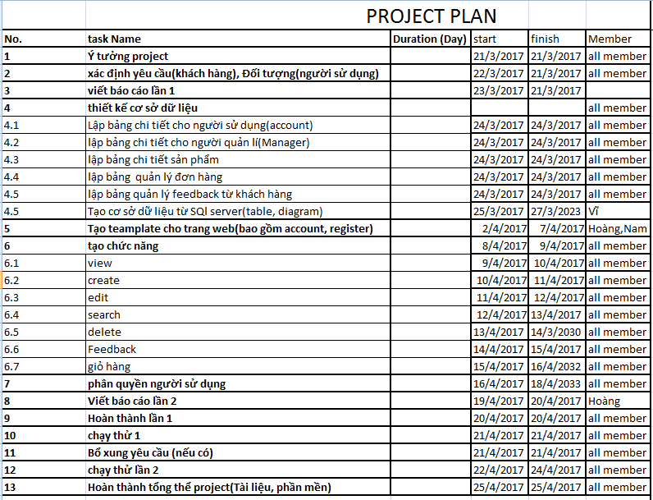

# VI. GUI PROTOTYPE

|  |
| --- |
| Munu barr |
| HORIZONTAL MENU |
| SLIDE BAR |
| FOOTER |

**Home Page**

|  |  |  |  |  |  |  |  |  |
| --- | --- | --- | --- | --- | --- | --- | --- | --- |
| **Logo** |  | | | | **Login** | **Register** | **Cart** | **Checkout** |
| **Home** | **Menu** | **About** | **Contact** |  | | | | **Search** |

|  |
| --- |
| **Slide bar** |
| **FOOTER** |

**Home Page**

|  |  |  |  |  |  |  |  |  |  |
| --- | --- | --- | --- | --- | --- | --- | --- | --- | --- |
| **Logo** |  | | | | | **Login** | **Register** | **Cart** | **Checkout** |
| **Home** | **Menu** | **Blog** | **Contact** |  | | | | | **Search** |
| **Contact** | | | | | **Contact info** | | | | |
| **Network Social** | | | | |
| **FOOTER** | | | | | | | | | |

CONTENT

|  |  |  |  |  |  |  |  |  |
| --- | --- | --- | --- | --- | --- | --- | --- | --- |
| **Logo** |  | | | | **Login** | **Register** | **Cart** | **Checkout** |
| **Home** | **Menu** | **Blog** | **Contact** |  | | | | **Search** |
| **Category** | | | **Item**  **Item**  **Item**  **Item**  **Item**  **Item**  **Item**  **Item**  **Item**  **Item**  **Item**  **Item** | | | | | |
| **Price** | | |
| **Range** | | |
| **FOOTER** | | | | | | | | |

Product list page

|  |  |  |  |  |  |  |  |  |  |  |
| --- | --- | --- | --- | --- | --- | --- | --- | --- | --- | --- |
| **Logo** |  | | | | | **Login** | | **Register** | **Cart** | **Checkout** |
| **Logo** |  | **About** | **Contact** |  | | | | | | **Search** |
| **Login** | | | | | **OR** | | **Another Service to login** | | | |
| **FOOTER** | | | | | | | | | | |

Login page

|  |  |  |  |  |  |  |  |  |
| --- | --- | --- | --- | --- | --- | --- | --- | --- |
| **Logo** |  | | | | **Login** | **Register** | **Cart** | **Checkout** |
| **Home** | **Menu** | **About** | **Contact** |  | | | | **Search** |
| |  | | --- | | **Register form** | | | | | | | | | |
| **FOOTER** | | | | | | | | |

Register page

|  |  |  |  |  |  |  |  |  |
| --- | --- | --- | --- | --- | --- | --- | --- | --- |
| **Logo** |  | | | | **Login** | **Register** | **Cart** | **Checkout** |
| **Home** | **Menu** | **About** | **Contact** |  | | | | **Search** |
| |  | | --- | | **Cart Summary** | | | | | | | | | |
| **FOOTER** | | | | | | | | |

Shopping cart page

|  |  |  |  |  |  |  |  |  |
| --- | --- | --- | --- | --- | --- | --- | --- | --- |
| **Logo** |  | | | | **Login** | **Register** | **Cart** | **Checkout** |
| **Home** | **Menu** | **About** | **Contact** |  | | | | **Search** |
| |  | | --- | | **Shopping Information** | | | | | | | | | |
| **FOOTER** | | | | | | | | |

Checkout Page

# VII. TECHNICAL

The technique used to build the Website:

* HTML5 & CSS3.
* Validation for bootstrap.
* Local Storage and Session Storage.
* Bootstrap form helpers.
* Horizontal fixed navigation.
* Material for bootstrap:
* JS popover.
* JS Scrollspy.
* Modal.
* Tabs.
* JS Carousel.
* Button.
* Table.
* Breadcrumbs.
* Form.
* …….

# VIII. REFERENCES

We consulted information on the websites:

* [**http://www.w3schools.com/bootstrap/**](http://www.w3schools.com/bootstrap/)
* [**http://fptshop.com.vn/**](http://fptshop.com.vn/)
* [**https://www.thegioididong.com/**](https://www.thegioididong.com/)
* [**https://developers.facebook.com/docs/plugins/comments/**](https://developers.facebook.com/docs/plugins/comments/)
* [**https://www.youtube.com/**](https://www.youtube.com/)
* [**https://jquery.com/**](https://jquery.com/)
* [**http://www.w3schools.com/**](http://www.w3schools.com/)

# IX. GUI OF WEBSITE

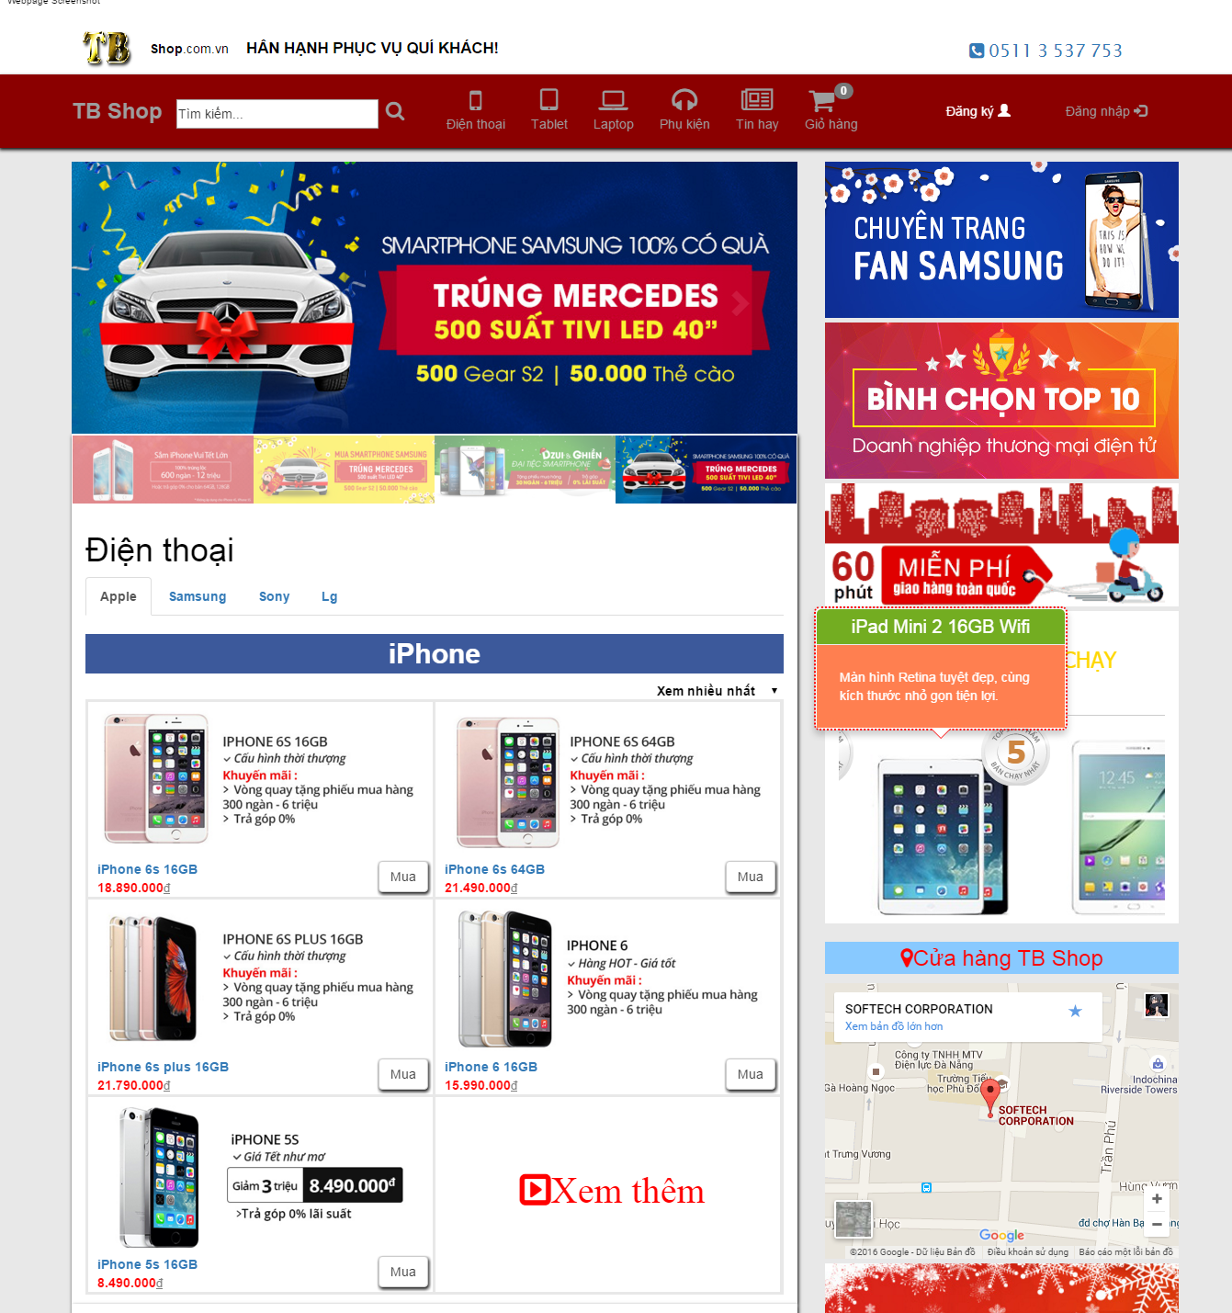

**Home Page**

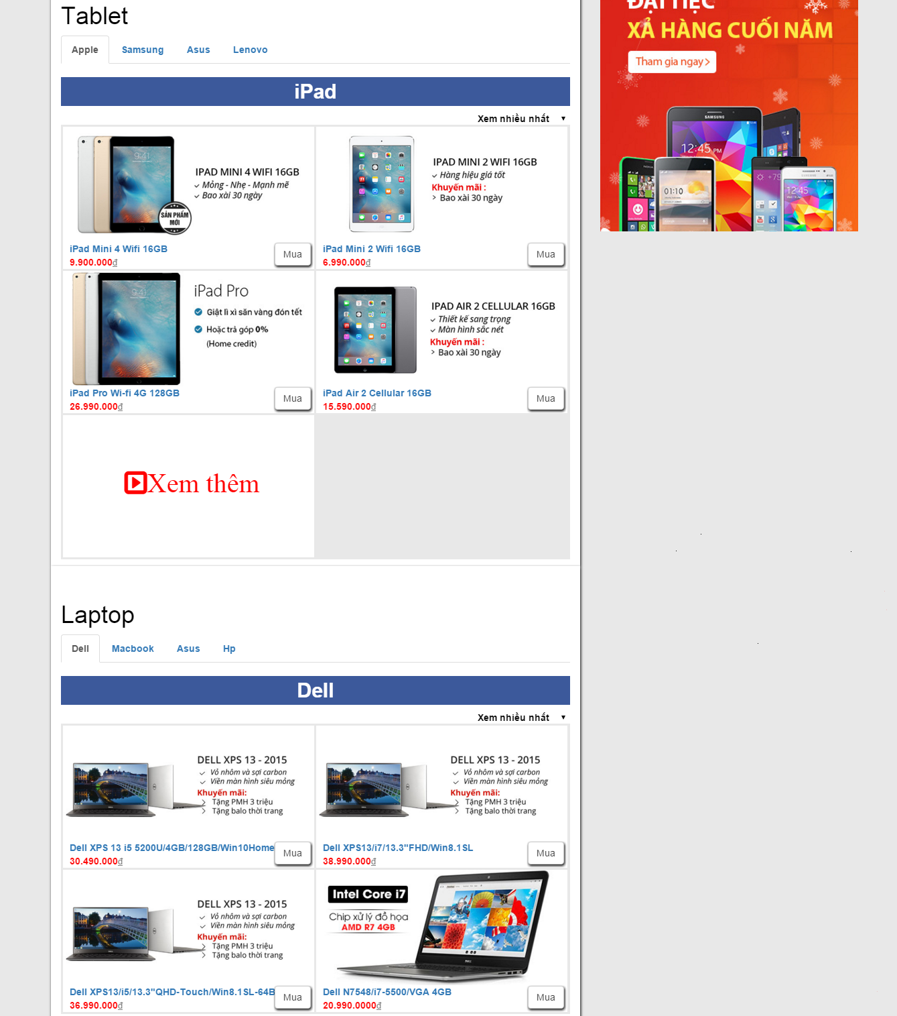

**Home Page**

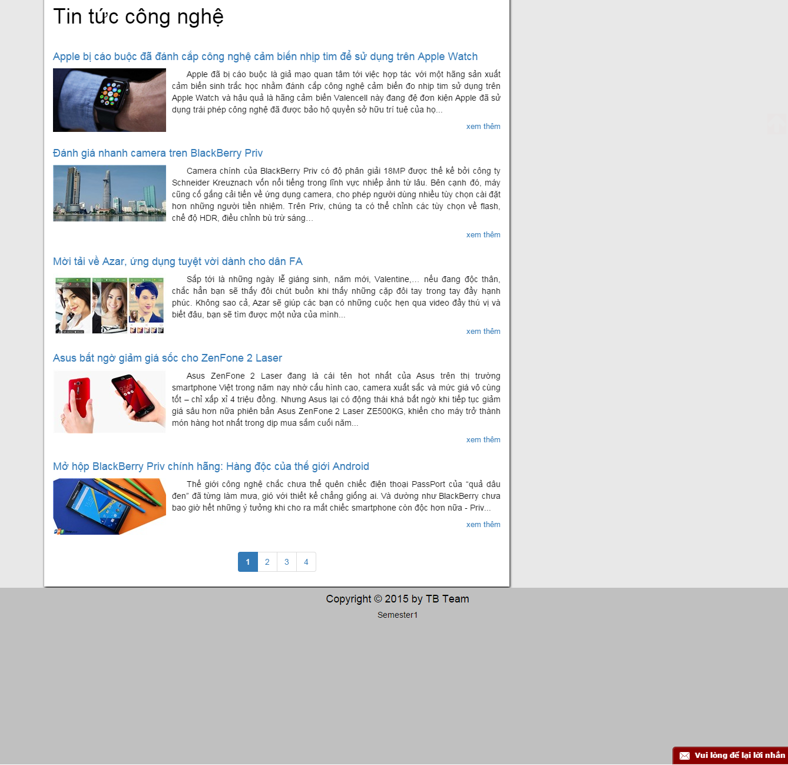

**Home Page**

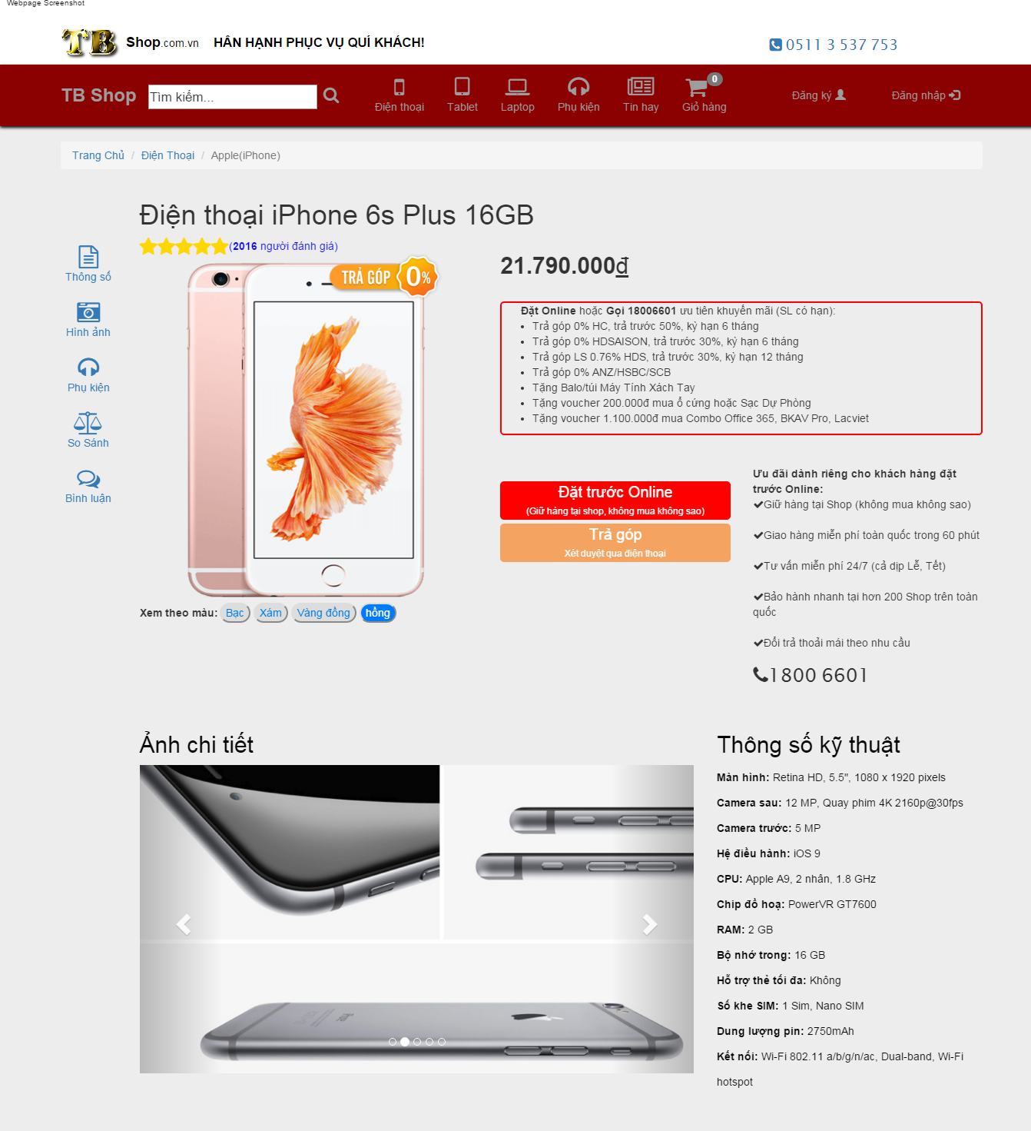

**Product Detail information**

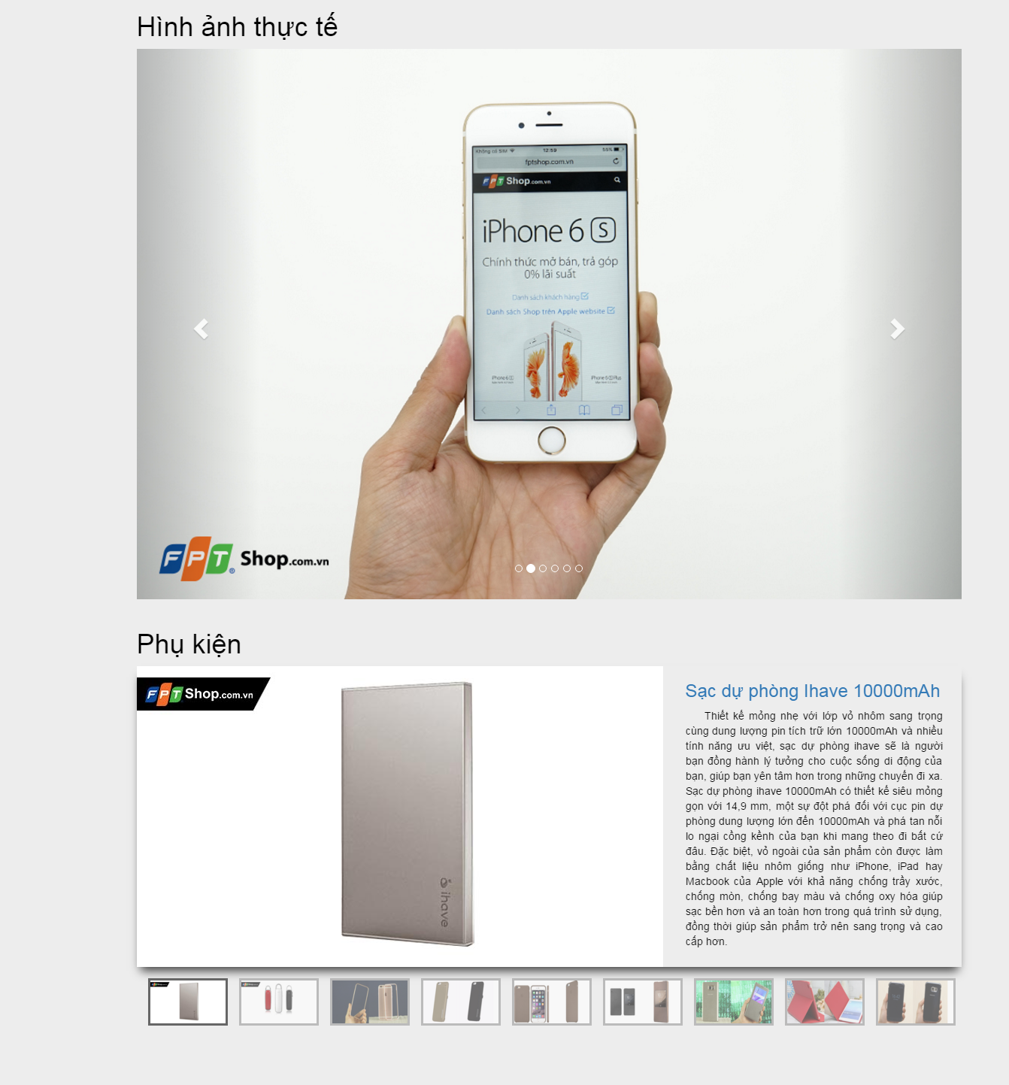

**Product Detail information**

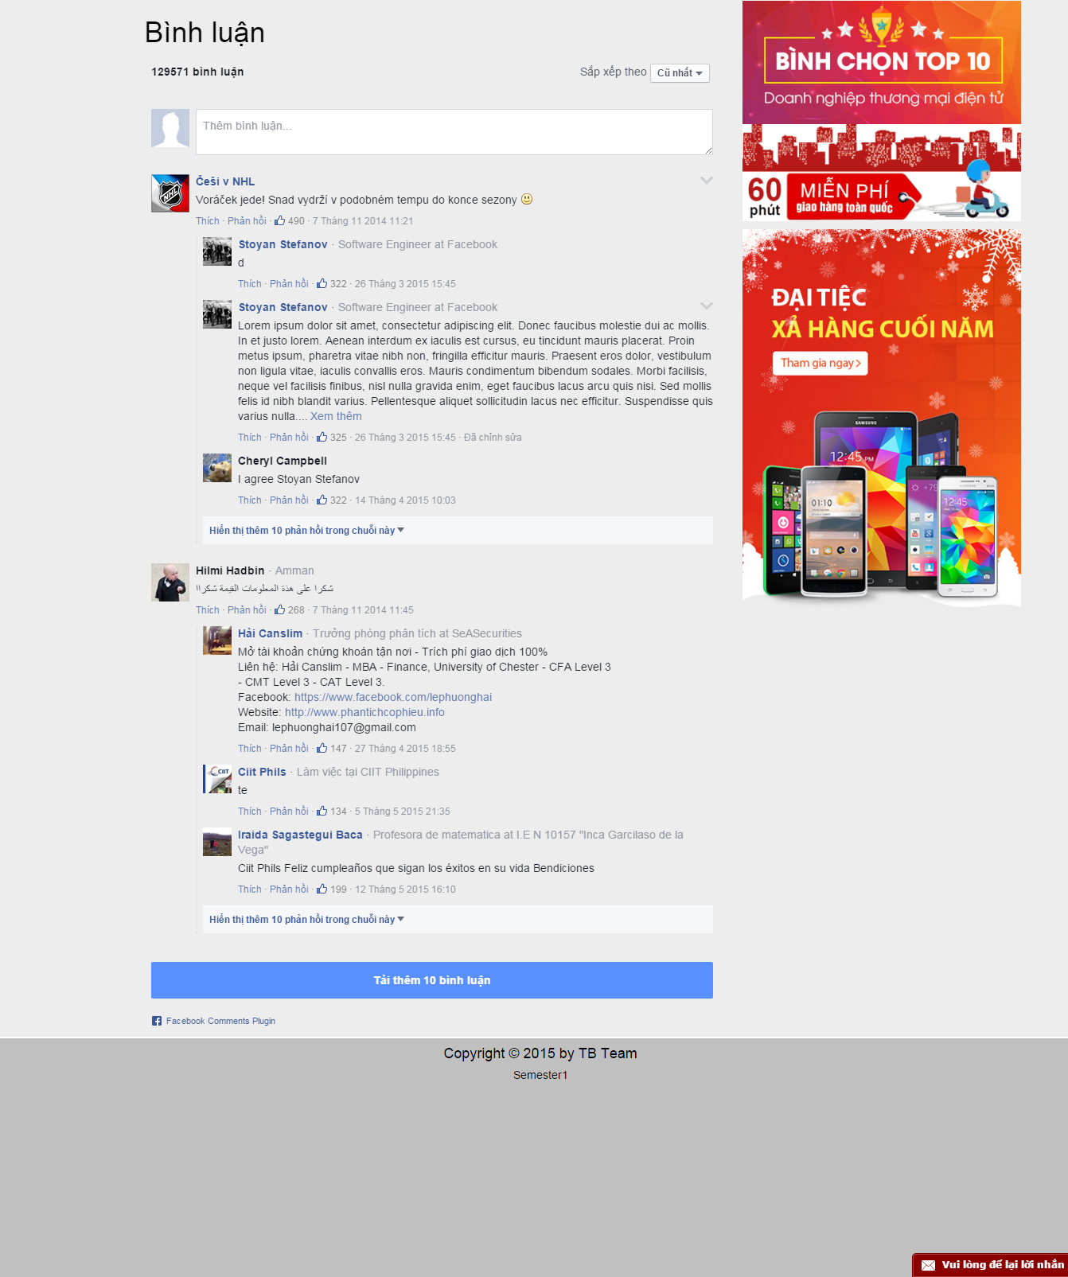

**Product Detail information**

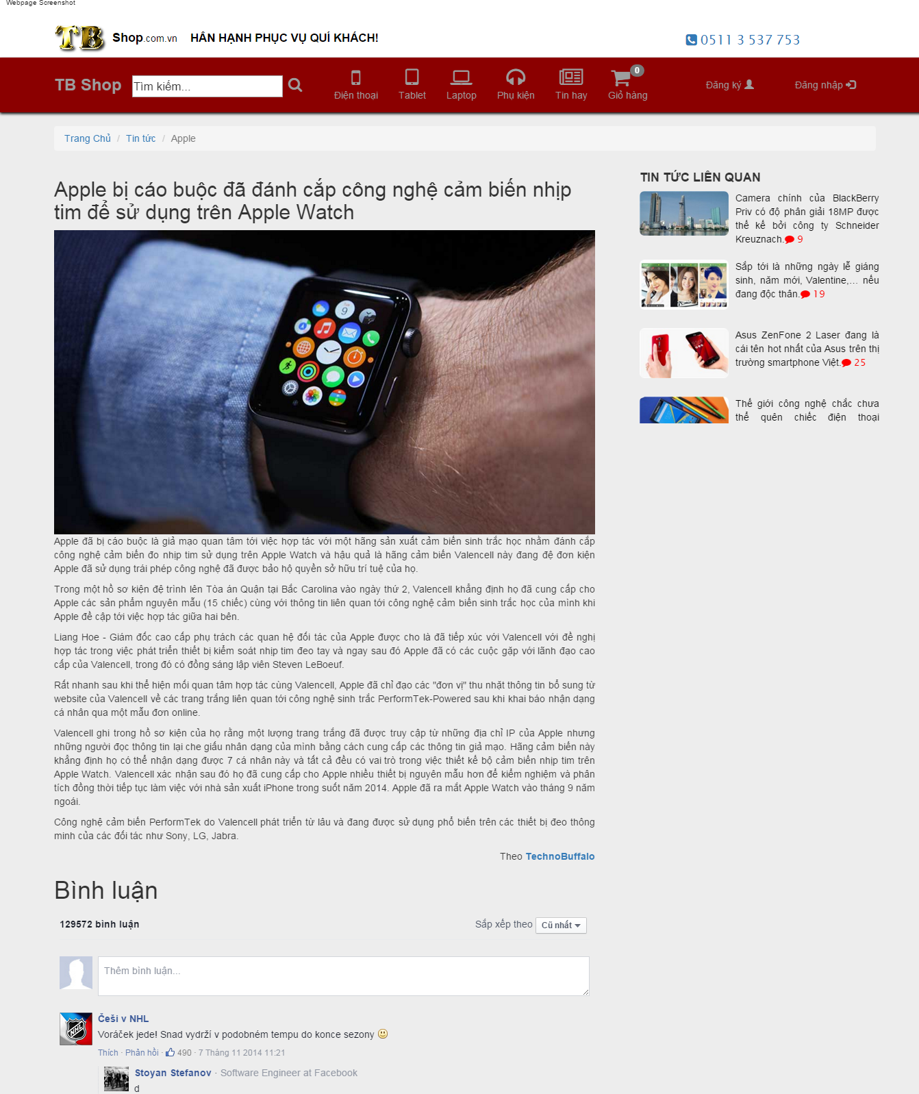

**News Page**

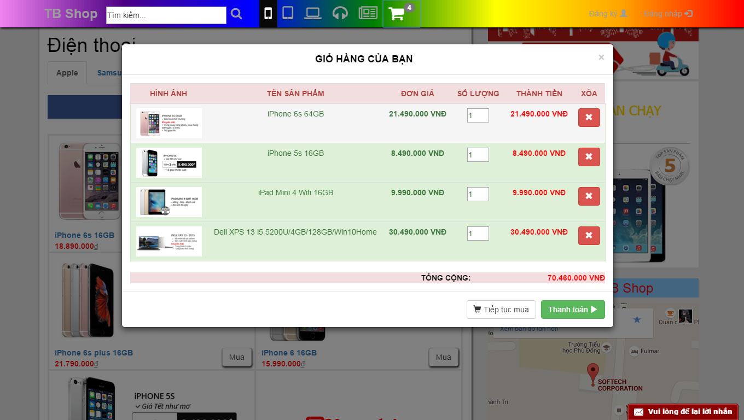

**Shopping Cart**

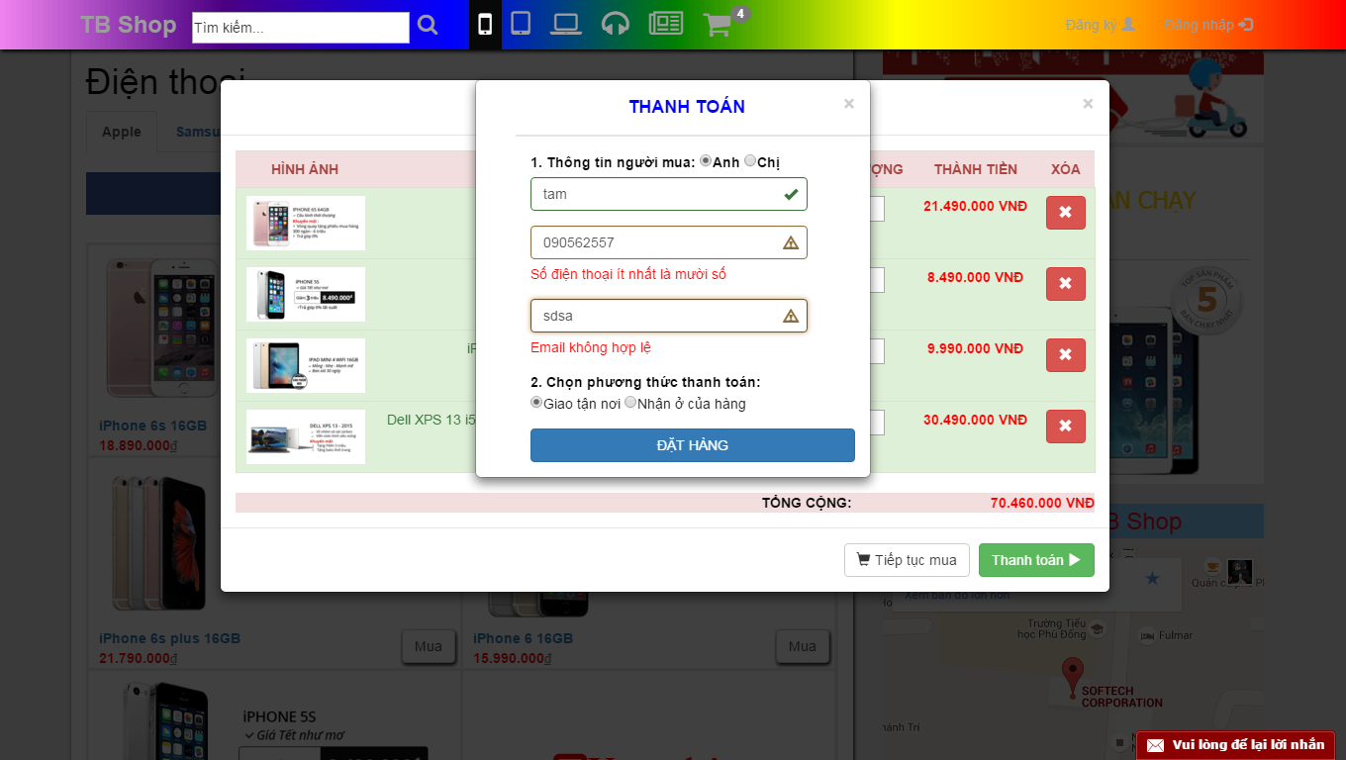

**Payment**

# X. CHECK LIST

## 1. Check List of Validation

|  |  |
| --- | --- |
| **Option** | **validate** |
| Can admin manage to the application? | Yes |
| Has the hardware and software been correctly chosen? | Yes |
| Are there functions for the user to enter their comment | Yes |
| Do all the options present in the application display the correct result? | Yes |
| Are there functions cart? | Yes |
| Are there function for the user buy product? | Yes |

## 2. Submission Checklist

|  |  |  |  |  |  |
| --- | --- | --- | --- | --- | --- |
| **No.** | **Particulars** | **Yes** | **No** | **N/A** | **Comments** |
| 1 | Isthe users table to login theApplication on the username and  Password? |  |  |  |  |
| 2 | Is there a form for users to enter  Personal information when buying  Or put item into the cart |  |  |  |  |
| 3 | Can the user to edit employee’s details after getting added? |  |  |  |  |
| 4 | Is the user able to find a product’s wherever they want? |  |  |  |  |
| 5 | Is the application user-friendly? |  |  |  | Windows GUI is familiar with everyone |